A student taking High Voltage Engineering Master course at Department of Energy Technology at AAU wants to do some measurement in the HV lab.

Exercise1 (15%)

A new capacitor should be designed. A specific kind of material is chosen as the dielectric in the capacitor, which is inserted between two parallel square plates. Suppose a uniform electric field exists in the capacitor.

(1) The relative permittivity of the dielectric is εr = 6. The square plate has a surface area of 3cm\*3cm. The gap length between the plates is 2cm. Please calculate the capacitance of the capacitor. (5%)

(2) Assume the dielectric in the capacitor is replaced by vacuum in the capacitor, calculate its new capacitance(3%).

(3) Schering bridge is used for measuring the dissipation factor tanδ for the capacitor in question (1) at 20 kV (AC, power frequency) and the result was tanδ = 0, 004. Calculate the current through the capacitor (result as a phasor, i.e. in complex polar coordinates) during the measurement and the loss P in the capacitor. What causes these losses? (7%)

Exercise2 (20%)

A single stage negative impulse generator, type b should be designed. Already chosen components are: Discharge capacitance C1 = 20 nF, load capacitance C2 = 3.2 nF, front resistor R1= 1200 Ω, discharge resistance R2 = 9500 Ω.

Temperature in the HV laboratory is 18°C and air pressure p = 1022 hPa

(1) Write down the output voltage when charging voltage V0= 60kV. Draw a graph of the impulse voltage waveform generated by the impulse generator using a sufficient number of calculated points of the curve V(t). On the basis of this graph, determine front time T1, time to half T2 and the efficiency η. Please show clearly on the graph how you do this. (15%)

(2) The student uses a high voltage divider to measure the output of the impulse generator. The unit step response of the divider is shown in the following picture. Please calculate the response time of this voltage divider as explained in Kuffel chapter 3.6.2. Explain carefully your procedure (you can write on the sheet with the figure and hand in). General approximations are of course acceptable.(5%)

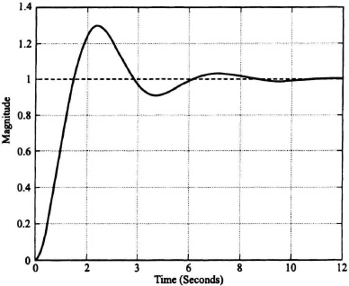

Exercise 3: (15%)

The insulation quality of a test transformer in the lab should be evaluated by partial discharge measurement.

(1) Draw the equivalent circuits of internal partial discharge and external partial discharge, and explain the components and the mode of operation. (7%)

(2) Explain why PD measurement can evaluate the insulation quality of the test transformer. (3%)

(3) The rated operating voltage of the transformer is 23kV. Now the applied voltage at the transformer insulation is V=25.3kV. The measured phase resolved partial discharge pattern is shown in the following picture. On the basis of this picture, explain whether the transformer has a good insulation condition or not? Please explain how you conclude this. (5%)

